**INSTALL ELASTIC AGENT ON HOST MACHINE AND SPIN FLEET SERVET ON IT**

Elastic agent are of two types

1. Fleet managed

2. Standalone

*Fleet managed are enrolled to fleet servers which are running on one or more elastic agents, these fleet servers manage all the other Agents using kibana UI and Agent policies at a central location.*

*Standalone agents are not centrally managed and have to be configured from elastic-reference.yml file.*

**Steps to setup fleet server and enrolled agent in it.**

1. **Click on Fleet in the left Menu.**

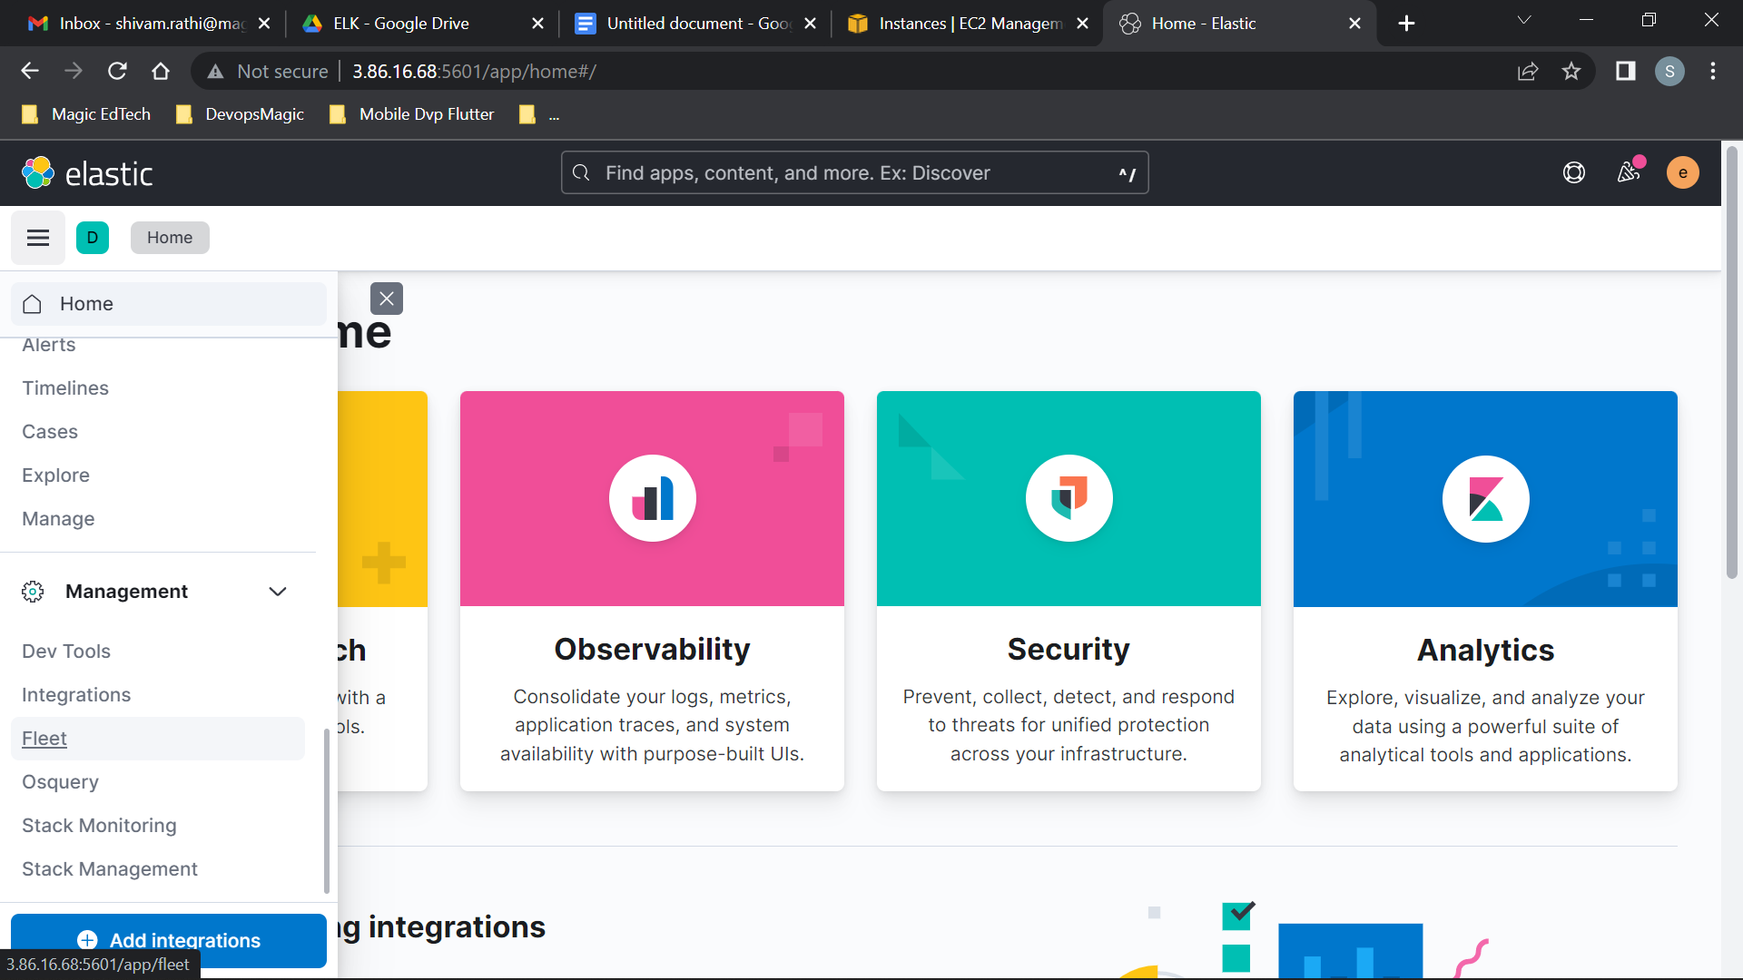

1. **Click on advanced.**

**Create a Policy for the Fleet server, this policy are the rules for the agent containing the fleet server.**

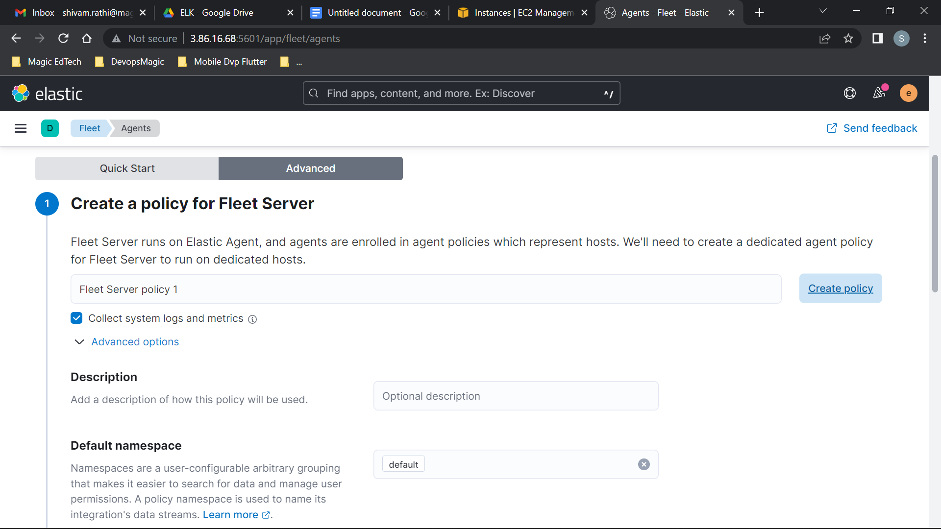

1. **Give public ec2 ip as host ip for the fleet server to which other agents will use to connect to the fleet server. USE PORT:8220**

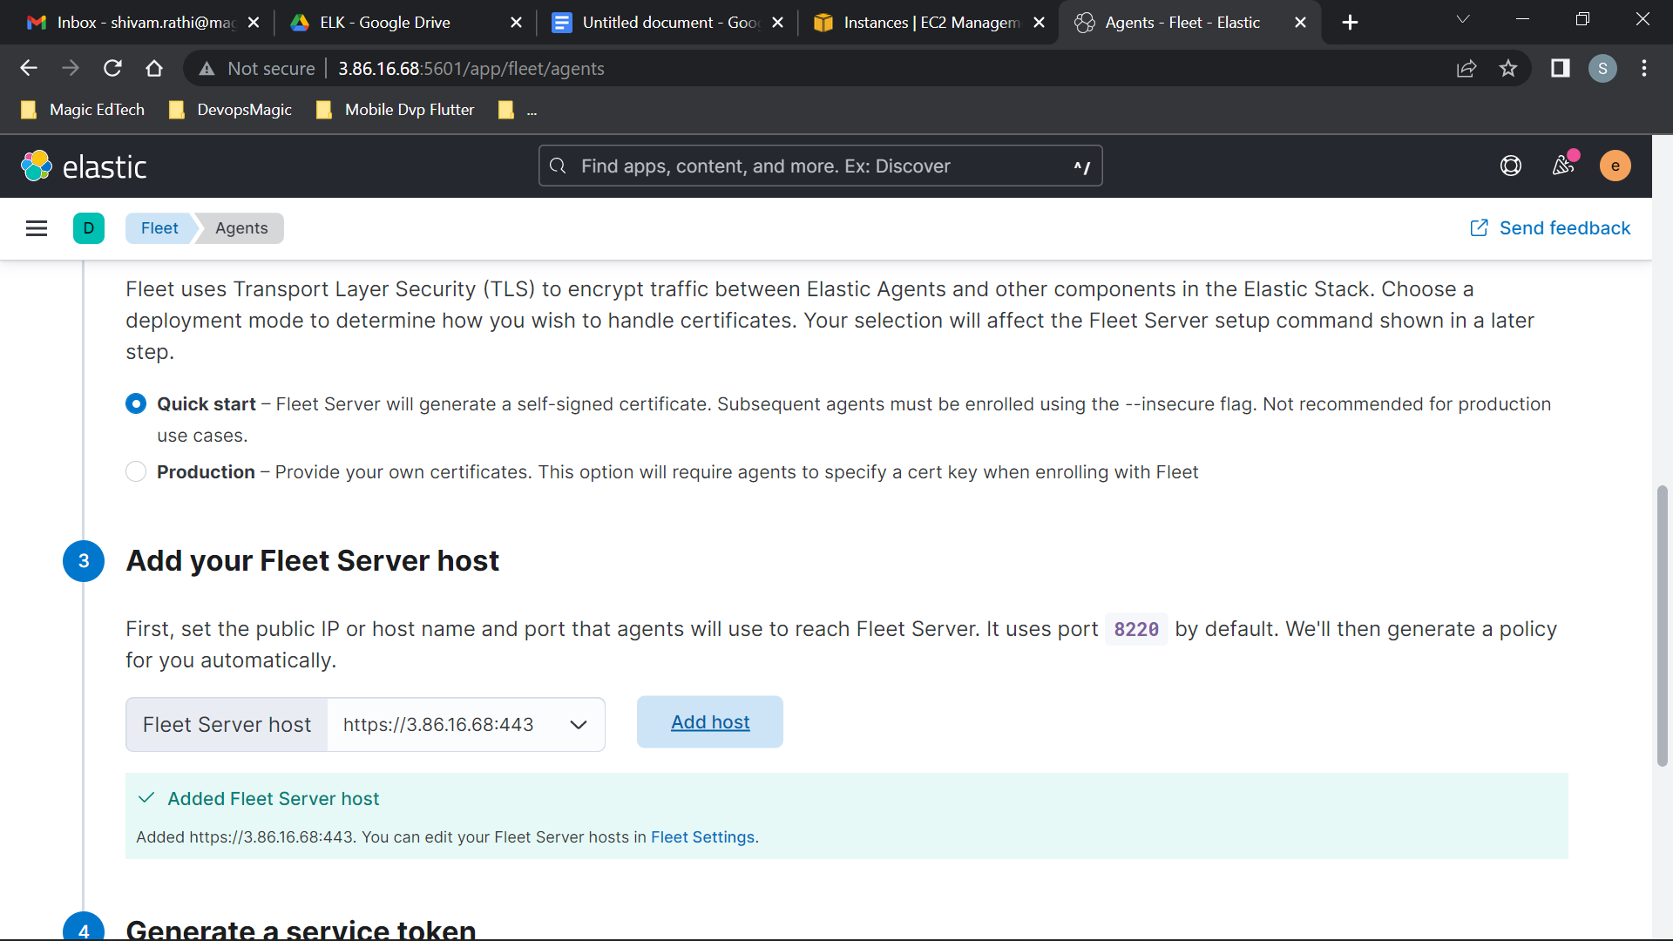

1. **Generate a service token , which is needed for the fleet server to write into the elasticsearch.**

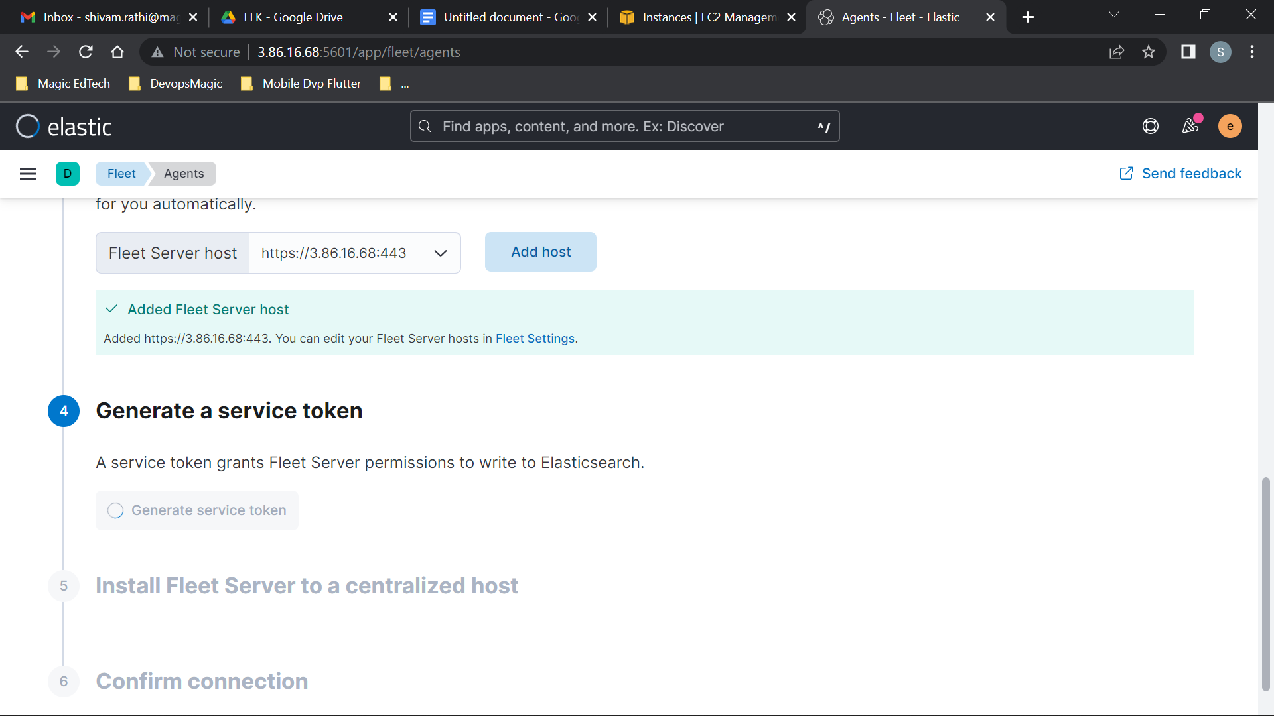

1. **Install the Elastic agent on the host machine using the commands.**

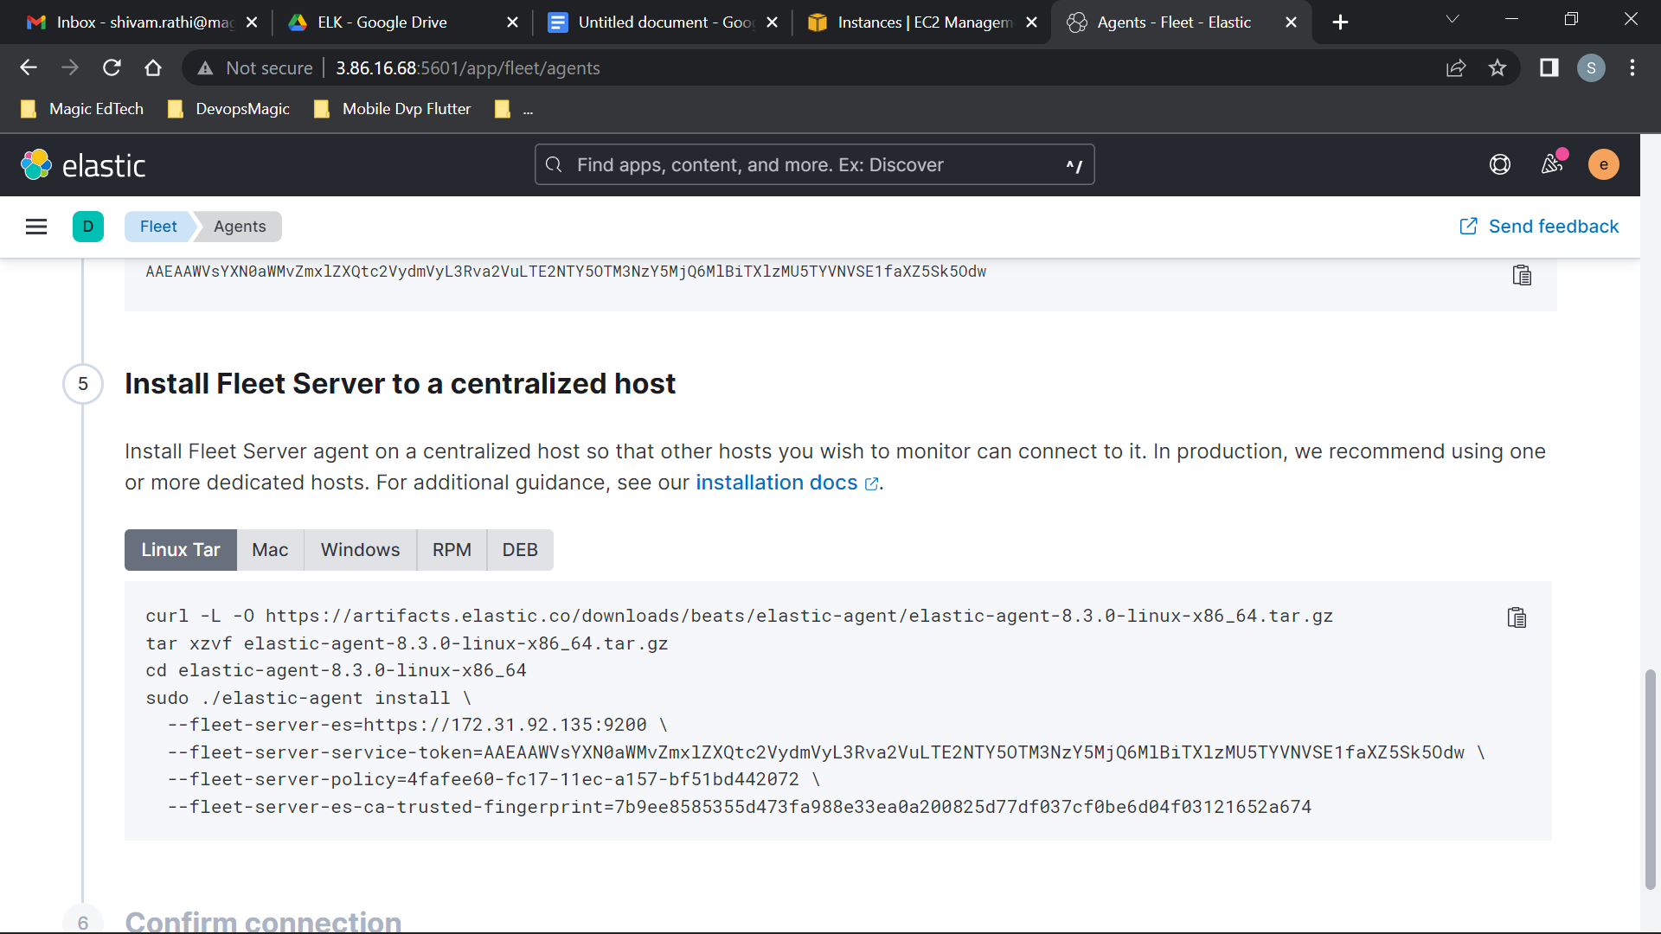

**After successful enrollment, terminal will show**

